UNIX Basic Command

1. To display the current working directory, the command is:

pwd

The output.

/home/trg1

2. Display the path to and name of your HOME directory.

3. Display the login name using which you have logged into the system

4. Display the hidden files of your current directory.

5. List the names of all the files in your home directory.

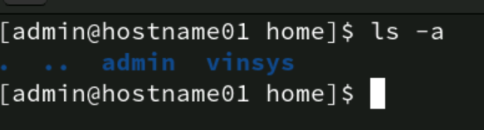

6. Using the long listing format to display the files in your directory.

7. List the files beginning with chap followed by any number or any lower case

alphabet. (Example , it should display all files whose names are like chap1, chap2,

chap3 ……., chapa,ahapb,chapc,……..)

8. Give appropriate command to create a directory called C_prog under your home

directory. (Note: Check the directory using ls )

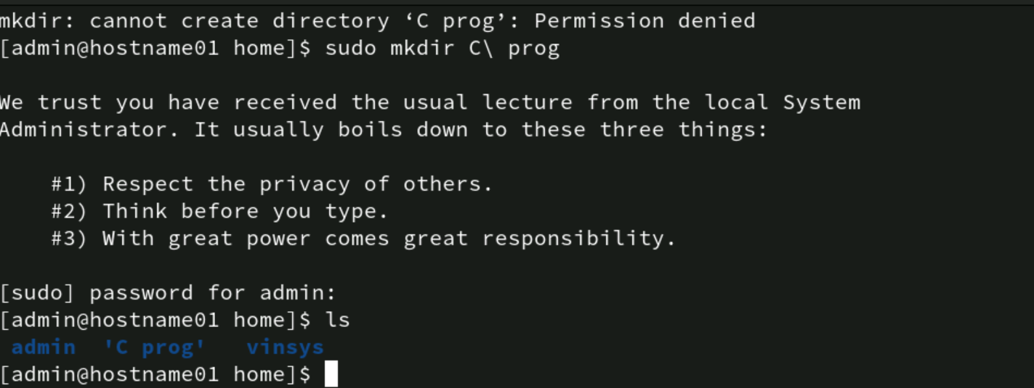

9. Create the following directories under your home directory. (Note: Check using ls )

newdir

newdirectory

10. List the names of all the files, including the contents of the sub directories under

your home directory.

11. Remove the directory called newdirectory from your working directory.

12. Create a directory called temp under your home directory.

13. Remove the directory called newdir under your home directory and verify the

above with the help of the directory listing command.

14. Create another directory directorynew under the temp directory.

15. Change the directory to your home directory.

16. From your home directory, change the directory to directorynew using relative and

absolute path.

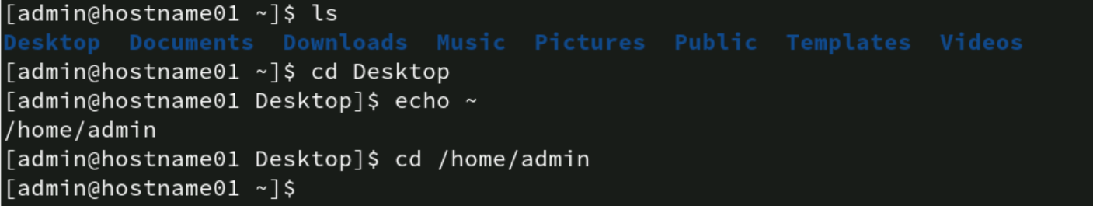

17. Remove the directory called c_prog, which is in your home directory.

18. Change to the directory /etc and display the files present in it.

19. List the names of all the files that begin with a dot in the /usr/bin directory.

20. Create a file first.unix with the following contents.

Hi! Good Morning everybody.

Welcome to the First exercise on UNIX.

Hope you enjoy doing the assignments.

